Assignment 3

All the given face images are read and stored in the numpy array. Their labels are created using the image name. Below are the steps taken before proceeding with the face recognition.

Cleaning the Data:- There were images where faces were not recognizable due to improper poses, bad lightening effects. These images were checked and handled manually.

Preprocessing:- Below are the steps taken to make the dataset more useful for the algo used in the later part of the document to perform face recognition. Many of the below listed steps are taken into consideration heuristically.
a) RGB to Gray scale Conversion
b) Histogram Equalization:- It is done to remove the intensity spikes and helps in spreading the intensity values over the image which has enhanced the global contrast of the image. Having implemented it, a slight accuracy improvement is observed.

Features Extraction:-
a) Face Detection:- Below 2 face detectors were implemented.
1.) Haar Cascade Face Detector:- It detects faces faster. However, It gives many false face detection and is unable to detect faces in images with little improper poses leads to the reduction in image dataset which further decreases the accuracy.
2.) HOG and SVM based Face Detector:- Dlib face detector which is based on HOG and SVM provides better accuracy than Harr Cascade Face Detector as it gives less false face detection.
b) Gabor Wavelet filters:- The Gabor wavelets have two desirable characteristics: spatial locality and orientation selectivity. Each Gabor wavelet captures the local structure corresponding to a particular spatial frequency (scale), spatial localisation, and orientation. Wavelets are rapidly decaying like oscillations that have 0 mean. Furthermore, their implementations in image processing helps in identifying the abrupt changes in signal (intensity values, texture patters, etc).
It helped in identifying edges, corners.

Gabor filters are applied on the above obtained face detected images.
Below are the parameter obtained after tuning hyper-parameters.

kern = cv2.getGaborKernel((ksize, ksize), 4.0, theta, 8.0, 0.5, 0, ktype=cv2.CV_32F).
Lamda value = 0.8
Gaussian scale = 0.5
kernel size(ksize)= 31x31
theta= range(1,8)

Total 8 filters are linearly combined, each having theta value in between 1-8. Below are the 8 gabor filters obtained.
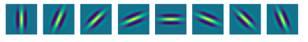

Image after applying above obtained Gabor Filter. It could be seen in the below image, above filters have identified edges, corners and texture which proved to be useful in face recognition.
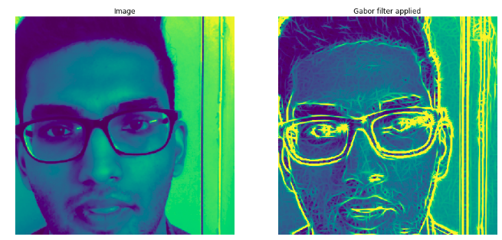

Face Recognition:-
Having the above features vector ready, our next task is to perform face recognition. Face Recognition is to be performed using
PCA, LDA, LBP and Open Face. Later, their accuracies will be compared.

Method 1:- PCA and SVM/Euclidean Distance

PCA(Principal Component Analysis):-
It is an unsupervised method which is used for dimensionality reduction.
It identifies the principal diagonals having maximum variance which best describes the data, by removing the strongly correlated features that indicate the redundancy between them.
Preparing the image dataset for calculating the PCA.
Above obtained image is resized to 50x50 (say NxN, this size is chosen after experimenting with various sizes) and is stacked to 1x2500. All the M images in the dataset are piled on top of each other results in an image data set of size MxN².

Working:-
def PCA_Image(Image):

1 Cov_Img = np.cov(Image)
# eigendecomposition of covariance matrix
2 eigvalues, eigvectors = np.linalg.eig(Cov_Img)
3 P = eigvectors.T.dot(Image)
return P,P

Step1:- It calculates the covariance of Image. Covariance tells the relation between two variables or features. In other words, it is the averaged product of the standard deviation of two features.

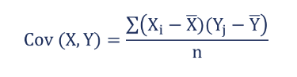

Step2:- It finds out the eigen values and eigen vectors of the above Covariance matrix. Eigen vectors are the vectors which are parallel and pointing in the same direction as the given vector in the same feature space.
Image fed to PCA should be of size MxN² as after computing Covariance, matrix size will be MxM so we will get M eigen values and corresponding M eigen vectors each of size Mx1.
Step 3:- This Step produces Eigen faces after getting the dot product of above obtained eigen vector and the image. Mathematically, this step will give us eigen values which when plotted looks like faces. Hence, the name Eigen Faces.

Below are the eigen faces and their corresponding images

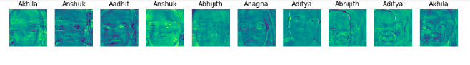
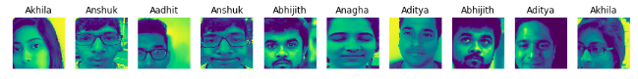
SVM:-
Not all above eigen features are useful in computing the accuracy. Selecting the eigen faces which results in better accuracy is important. Therefore, it is also an important Hyper-parameter to consider along with the parameters of SVM.
Below are the parameters of SVM selected experimentally after having checked for listed parameter ranges:-
Coeff(C) - (8-50)
degree- (3 default, 4-10)
gamma- (0.001 – 30)
kernel – (Linear, rbf(default) and poly)
Eigen faces - (1-300)
SVC(C=8,degree=10, gamma=0.001,decision_function_shape="ovr")

We found better results with the Eigen faces between 5-8. Depending on the data set distribution among train,test and validation.
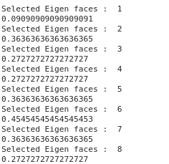

Accuracy of 45% is achieved with the top 6 Eigen faces i.e. 6 max eigen values

Gender Recognition:-

Pre-Processing:-
Same pre-processed data set will be used as above. Since, its a gender recognition, so labels need to be updated as Male and Female.
Required changes were done by mapping names under required category. Pre-processing used were as follows:-
1.) Convert RGB to Grayscale
2.) Histogram Equalization
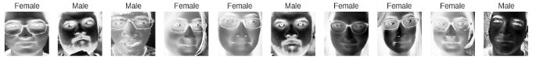
Features- Extraction:-
Features Extraction process also remained same as face-recognition done using PCA and SVM. Various other methods were tried but it gave good results on the same feature-Extraction.
Method used in feature- extraction:-

1) Gabor Wavelets filter- It covered all the feature extraction needed for gender recognition also. i..e. Corners detction, edges detection and texture analysis. Moreover, In gender recognition texture analysis can play more role i.e. beared on faces, texture of the skin can clearly identify gender of the image fed.

Predictions:- Approach used is to decrease the feature space dimension, so that better accuarcy can be achieved when feeded to ML models.
Approach 1:- PCA and SVM
Feature space dimension reduction is done using above implemented PCA. The Eigen values(faces) obtained were sorted in decreasing order, as higer eigenvalues contains more information or variance. Again, this is a hyper-parameter which need to be considered during training and testing.
ML model used is SVM. SVM parameters when tuned turns out the same as above discussed parameters which are as follows.
SVC(C=8,degree=10, gamma=0.001,decision_function_shape="ovr")

Below are the accuracies achieved using different Eigen faces.

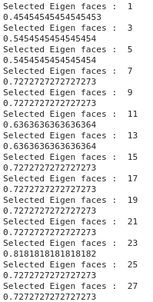
Eigen faces were taken in the range (1-200).
Highest accuracy of 81% is achieved with 23 top Eigen faces.

